Consumer Perception Survey (CPS)

For Adults

May 20-24, 2024

[Counties/providers may tailor this flyer as needed.]

Tell us what you think about the services you are receiving at this program.

Complete a voluntary and confidential survey.

Choose how you want to participate:

- Secure online survey link for this program:

ADULT
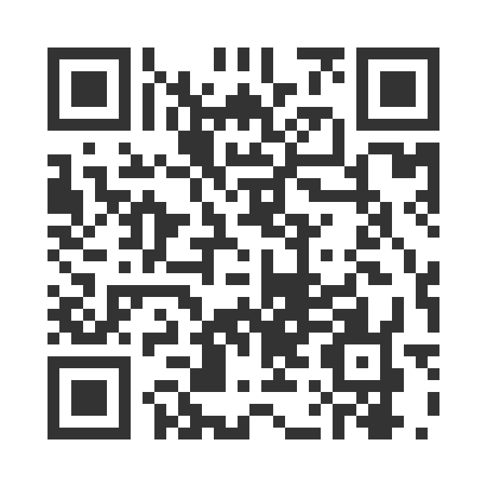
https://uclahs.fyi/Adult

ADULT (+QOL)
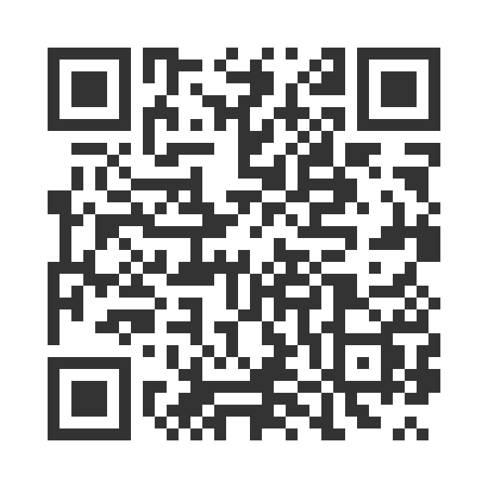
https://uclahs.fyi/AdultQOL

- Paper survey form (ask program staff for a form)

Ask program staff if you have questions or would like assistance with the survey!

Thank you for participating in this important survey!

